**Cordwood at Cedar Eden: “The Pattern that Connects”**

by Tom Huber

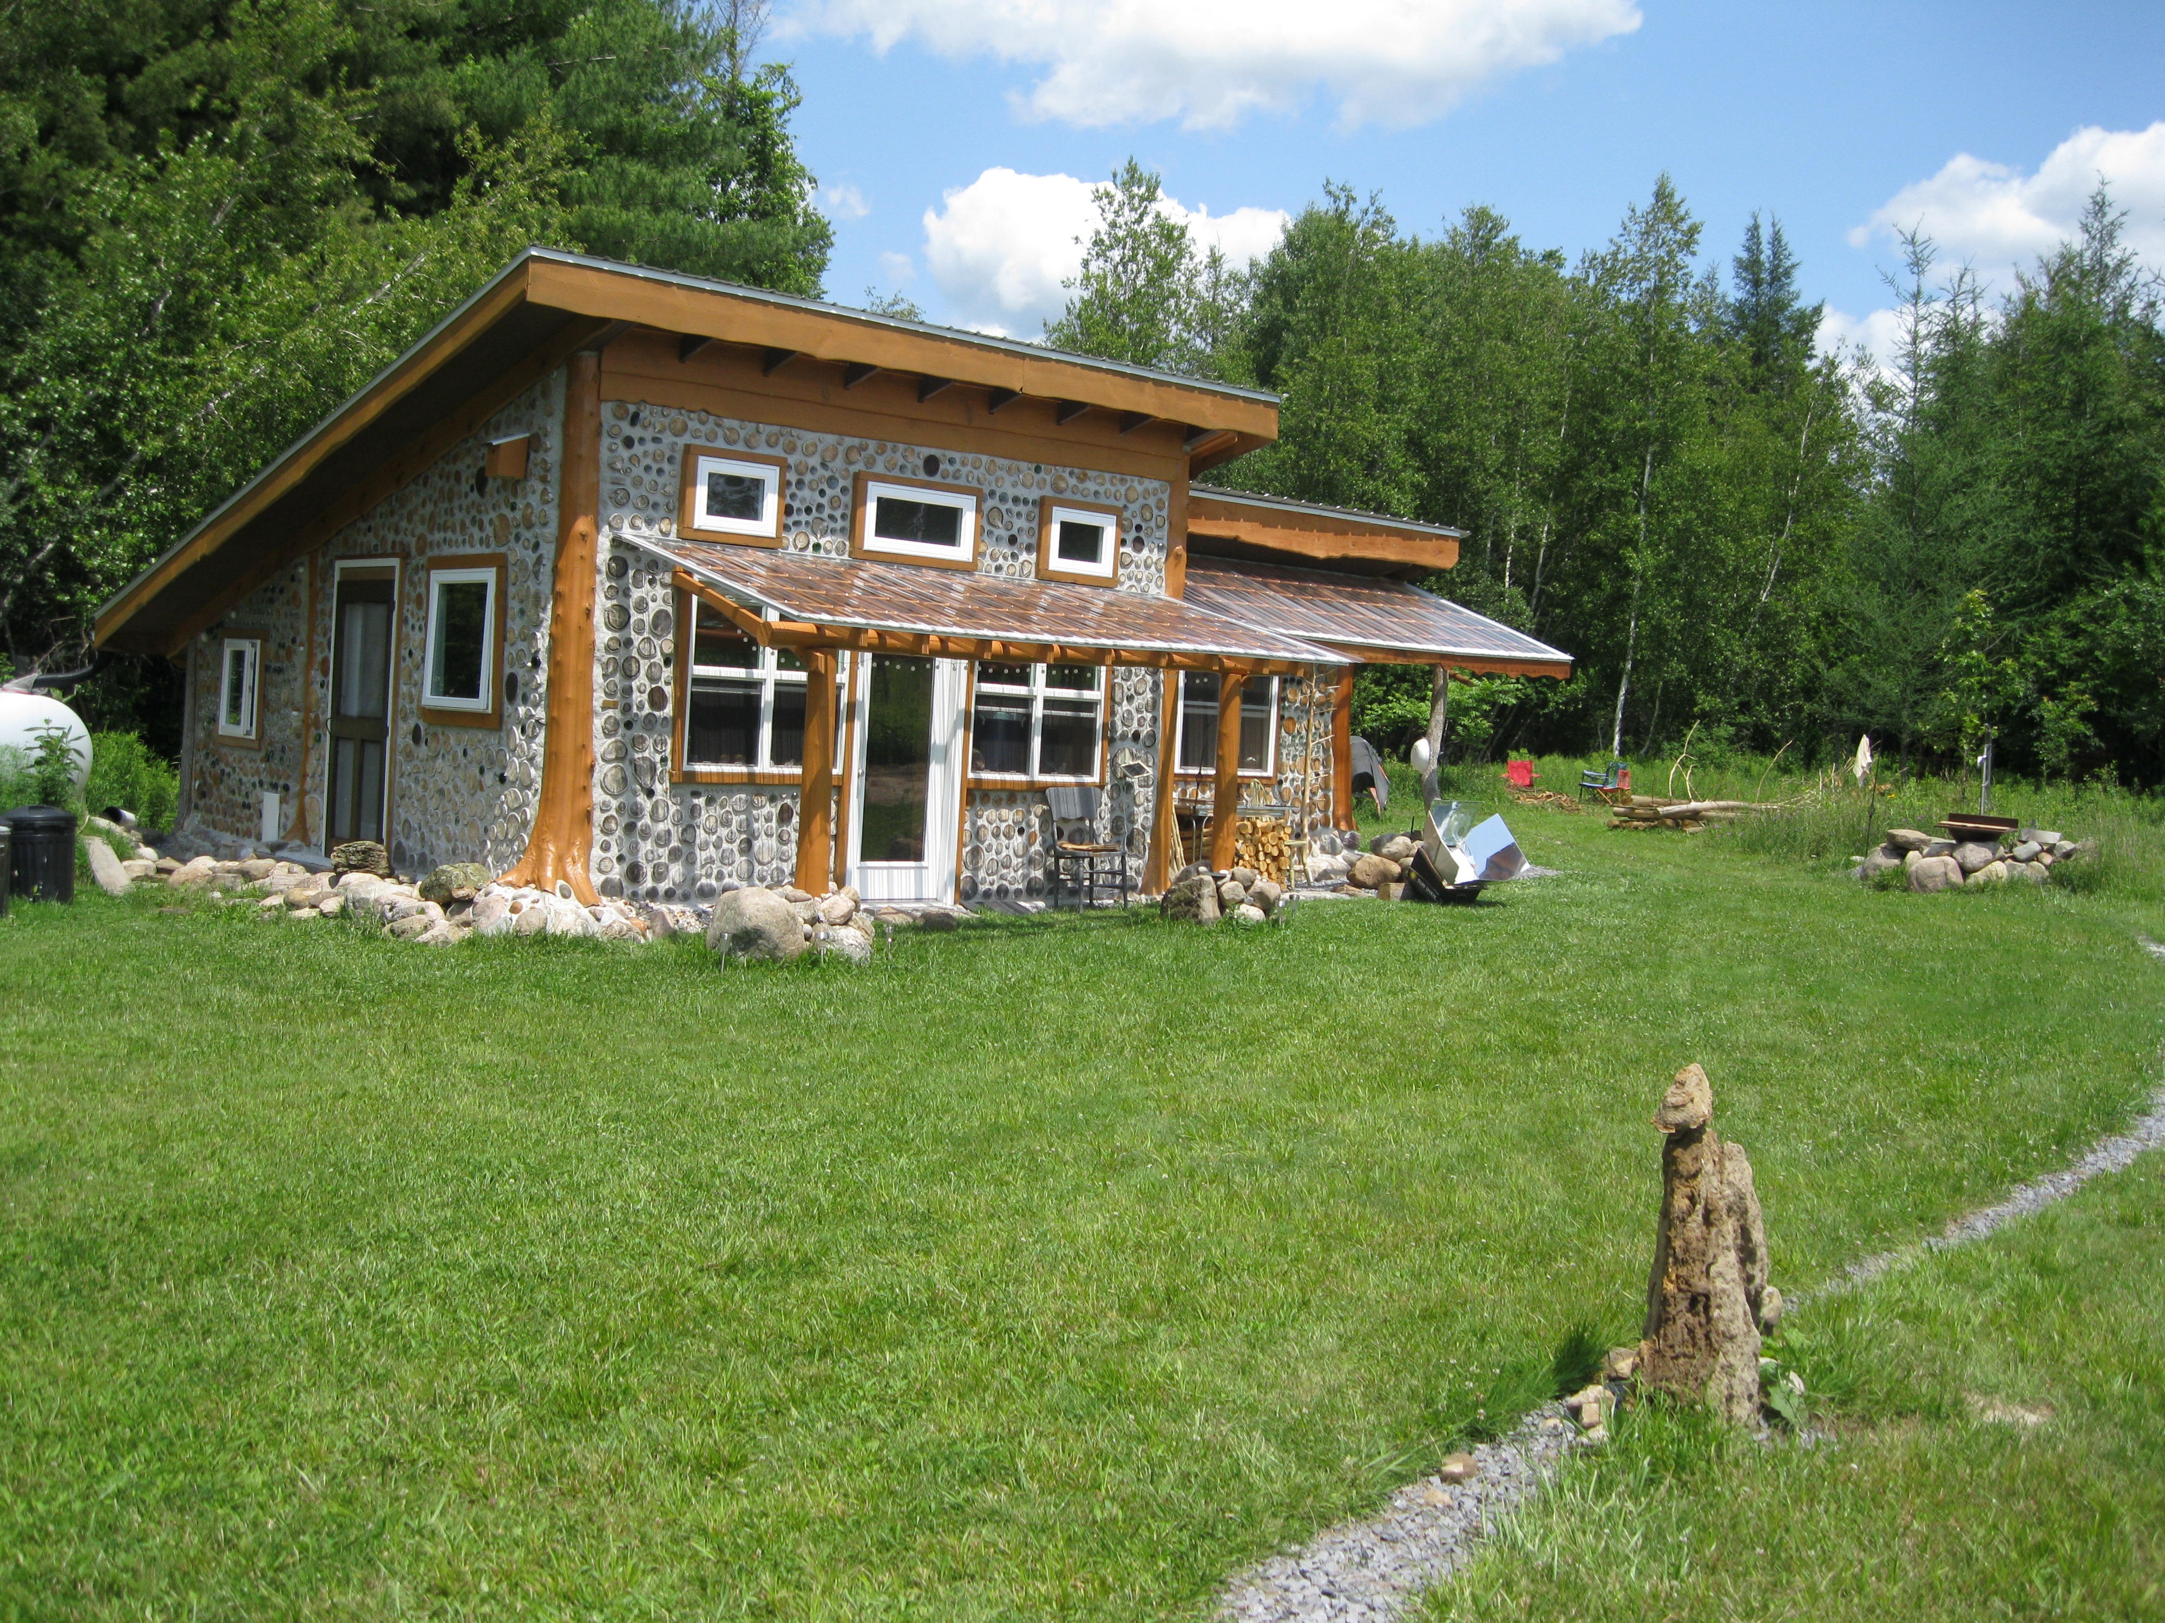

Cordwood cabin with additions at Cedar Eden (Potsdam, New York)

**Introduction**

Gregory Bateson coined the phrase – “the pattern that connects” back in the 1970s to describe an aesthetic whose core principle is one of unity. It signaled a paradigm shift away from reductionism to a holistic, synergistic worldview where the whole is greater than the sum of its parts. Everything in nature is connected, which includes the mind and actions of humans. This paper seeks to elaborate on this principle as it pertains to the natural building method of cordwood masonry at Cedar Eden, a hobbit-scale farm in Potsdam, New York. There are many reasons why humans build structures using cordwood masonry. Perhaps the greatest of these is the psychic drive to create beauty as a type of harmonious interaction with the natural world. Perhaps this drive in some is as strong as the drive to procreate; both involve a creative impulse to bring something new into the world.

Cordwood masonry, quite simply, is the pattern that connects at Cedar Eden. The property consists of 69 acres in total with about 40 acres forested primarily in Northern White Cedar (*Thuja occidentalis*). This species is also referred to as the American Arborvitae or Tree of Life due to the medicinal properties of the sap, bark, and twigs. For those of us in the cordwood construction community, white cedar is one of the most desirable choices of cordwood due to its natural decay resistance, high insulative value, fast drying and low shrinkage properties. It is also a beautiful wood to work with, given its wonderful “cedary” smell and ease of removing the bark when cut in early spring and throughout the growing season. Personal confession – I have a love affair with cedar!

Knowing that I possessed a strong motivation to continue building with stone and cordwood (like previously in Michigan), the prodigious piles of stone and the considerable cedar forest strongly suggested the rightness of purchasing land north of the Adirondack Park in St. Lawrence County. The rich soils, open sky with meadow views, wind power potential, and ample rainfall also promised a good fit for homestead living. These are all critical elements in the larger whole when I refer to “The Land” or “Cedar Eden.” To the degree that I understand and stay true to these life-enhancing, complex, interrelated patterns one could say that my habitation on The Land is successful. To the degree that I live in a way that only supports the human side of the great interplay of life, it could be said that such building projects are unsuccessful or miss the mark. In this paper, I will discuss some of the larger principles and patterns that inform a way of being in this particular place while also making mention of some of the particularities related to an evolved form of cordwood masonry involving cellulose enhanced mortar.

**Place-based Design Considerations for Cold Climates**

A building that works must first be guided by the locality where it is built. When building in cold climates – such as the Adirondacks in Northern New York - a successful building project is benefited by facing the structure true south for solar gain (for light and heat), ideally with earth-berming to the north and good protection from the wind. Designing the southern edge of the building carefully (edge effect) will provide positive multiple functions over the lifetime of the structure. Also, smaller, compact structures are easiest to heat and keep cool, especially when they are well insulated and have plenty of interior thermal mass, which makes cordwood masonry an ideal and durable natural building method. Redundancy in heat sources (passive solar, wood stove, masonry stove, etc.) is especially helpful for consistent thermal performance during harsh winter conditions. The Cedar Eden project was first informed by these design considerations related to place.

**The Hobbit Way of Homesteading**

In 2005, when we left our homestead in Michigan to move to the Adirondack Mountains of New York state, the only thing that was clear at the time was my new job at Paul Smith’s College. However, after getting settled the first year, the search for land began again which led to the discovery of Cedar Eden, located a little over an hour away from where we purchased an older passive solar home near the college. Once we closed on the land, we transitioned from tent camping to purchasing a used camper (1st year) to building a tractor shed (2nd year) to converting it to a small cabin (3rd and 4th years) followed by an addition to the north (5th year) and the bedroom addition to the east (6th year). We also had an Amish-made shed transported to the property and added a lean-to addition to its north side. Since most of the work was completed on weekends, it was important to apply an incremental, step-by-step approach – what I call “the Hobbit Way.” This method of homesteading allows one to get a foothold on the land (controlled front) from which to expand each season and passing year. Looking back, I probably should’ve had the Amish shed positioned on the land before building the cabin for multiple purposes: tool storage, compost toilet, solar shower, etc. The cabin’s metal roof was strategically planned for a water catchment system from the beginning to supply plenty of water for masonry work, watering gardens and trees, etc. More recently, in 2014, we had a well drilled and outfitted with a Bison hand pump. Small solar panels are used for a couple of lights for the camper and the cabin.

**A Cabin with Four Doors**

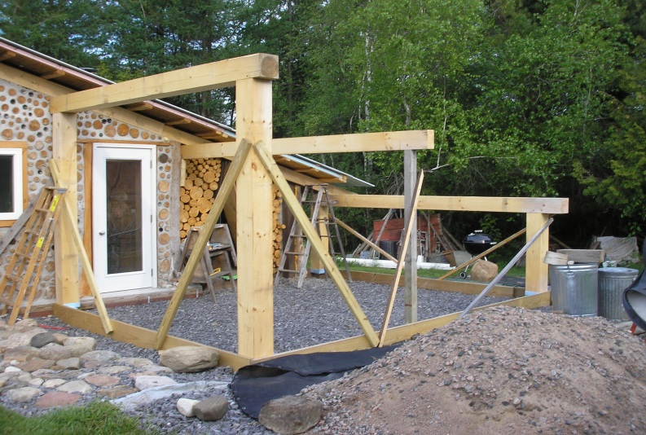

From the outset, the plan was to build a passive solar cabin with four doors to allow for four different additions: a bathroom/storage area to the north, a bedroom to the east, a solar space/greenhouse to the south and the main living addition to the west. This west addition, to be completed last, will include an upstairs loft, master bedroom and bath, kitchen with masonry heater, and wood cook stove. The south-facing roof of this main living addition will also serve as an active solar power plant for the homestead. In front of the structure, an edible pond garden with cordwood sauna is also being created in small stages. All along the way the design is kept open to change so that both a childlike wonder and high functionality can be incorporated. I no longer claim to know the overall best way to design and build hobbit projects. Instead I take it one season at a time ...

Every step of the way, a conservative approach is taken for off-grid, mortgage-free living. For example, the main cabin can be easily heated first with the small Jotul wood stove. Once the thermal mass of the walls are charged, a door can be opened to direct heat to the other additions. This is helpful when coming over to Cedar Eden in the middle of winter when it’s -10 degrees F.

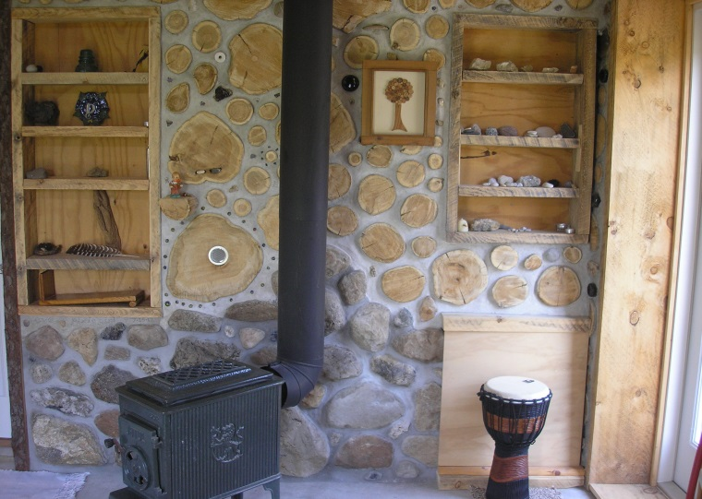 The site was carefully selected so that the cabin would be nestled in a cedar grove facing south for passive solar gain while providing protection from the strong western wind. Attention to drainage patterns resulted in digging a trench and installing a drain tile for directing water flow around the buildings given the northwest slope of the land. The rich, fertile topsoil from the trench digging was placed around the perimeter of the pond for the permaculture garden.

By employing the add-on strategy, each new addition brings a sense of completion to that particular stage of living, whether it be as a camp, refuge, retreat, small farm, or fully functional homestead. The small-scale additions themselves can also be constructed to be even more efficient by incorporating shelving (photo, left) and cabinets into the walls themselves. We worked in a large compartment for storing clothes in the bottom section of the south wall of the bedroom addition by insulating the outer wall with foam and screw-attaching 5” log-ends abutted to the plywood-foam panel. Mortar was then fitted around the shorter log-ends with the whole section tied in to the rest of the wall on the sides with longer 16” log and bottle-ends.

The overall goal of these methods is to have each stage completed by the end of a particular building season, in order to keep a sense of accomplishment moving the process forward. A long-term option also exists as a multi-generational habitation on the land. Whether or not this actually happens depends on many variables often beyond the control of the first family …

**Intentional Patterns – The Nature of Order – Building as Sacred Practice**

In an earlier article (Huber, **CoCoCo/05**), an overview of applying Christopher Alexander’s work on pattern language to cordwood construction was discussed. Pattern language refers to incorporating specific individual design elements to tell a story of unity, life essence, centeredness and wholeness. Alexander discusses his thinking in more detail and depth in his four-volume series, **The Nature of Order.** In this work, he distills 15 integrated design properties that lead to the creation of buildings that have living structure, centered wholes, and tranquility. The properties inform patterns which resemble ancient and primitive forms from the deepest archetypes (folk architecture). The intentional properties provide an essence of life-giving qualities that he originally referred to as a “timeless way of building.” All of these qualities provide a greater personal feeling for the structure. And, Alexander believes we feel happy in the presence of deep wholeness. This is perhaps why cordwood buildings work so well, and vinyl-sided manufactured houses do not.

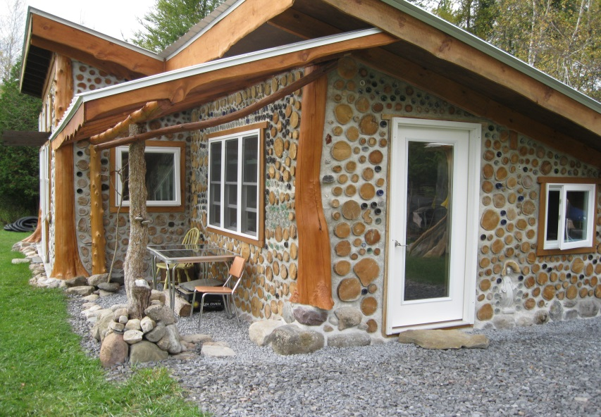 If I understand correctly, Alexander believes that great works contain a special quality of relatedness of ourselves to the universe – another form of Bateson’s *the pattern that connects*. The task of building was understood by the master builders as a spiritual exercise; a direct attempt to come face-to-face with the Luminous Ground (also known as the Void or Emptiness) of the universe. Although the Luminous Ground is nameless, and without form, it can be expressed in intensely personal ways from the deep eternal self. It is this numinous experience which we feel at certain sacred places (forests, hobbit hills, meadows alive with wildflowers), which Alexander refers to as a *quality without a name* that informs a timeless way of building.

In the building process at Cedar Eden, we have continued to incorporate one of Alexander’s most important patterns, “Light on Two Sides of Every Room” through the use of full-lite doors, south-facing windows, and tubular skylights. We’ve also found helpful the use of clear, polycarbonate roofing material for adding on a solar/moon porch to the south-side of the bedroom addition to allow for passive solar gain, but also creating greater functional and aesthetic space. This also helps protect the walls from weather, directs moisture away from the building, and also provide multi-use function for the south-edge. The generous “solar-collector” windows, in addition to allowing for passive solar gain and natural daylighting, also provide a way to bring the outside world inside for living more in tune with the beauty of the place. Essentially, multiple benefits are provided by one single element, which relate to a primary pattern.

The protected transitional spaces give a place to work outside in all but the harshest weather conditions and provide outer passageways for accessing areas outside the cabin. Here is where wide overhangs, awnings, and porch spaces expand the durability and functionality of the living structures for low cost investments of time and materials. Adopting insulated stonework as a base for cordwood walls also lifts and protects the log-ends for long-term longevity. Buildings “live long and prosper” by keeping their feet dry. Inside too, “hobbit-scale” passageways can be created when the residents are on the shorter side of average height.

**Retreat from the World**

So how many functions can be provided by a building with cordwood walls? Especially walls made with “Things from Your Life” (Pattern #253, C. Alexander) – unique bottle-ends, stones, quotes written in mortar, shelf mushrooms, and other special objects? What if these walls were used to provide safety, privacy and comfort as well as a certain resonance with one’s personal narrative during an experiential form of psycho-spiritual therapy known as Holotropic Breathwork? In my last holotropic session in the cabin at Cedar Eden, I finally worked through a certain emotional funk I’d been feeling since late fall and the onset of winter. Also during the session I was internally bombarded with a creative brainstorm of ideas related to organizing an annual Adirondack Fungi Fest every October – [www.adkfungifest.org](http://www.adkfungifest.org). One thing I found curious, is that at the beginning of the session I was feeling a bit apprehensive without having a “sitter” for my session. I looked out the full-lite door to the west of the cabin and saw a deer browsing a few cedar trees. The deer saw me, but still stayed near the cabin for the first hour. It’s the first time I’ve had a deer for a sitter! For more information about this method, Google “Stan Grof Holotropic Breathwork.” Stan has more experience assisting folks with holotropic states of consciousness than anyone else on the planet.

**Cellulose Enhanced Mortar**

I have taken to coining a phrase that relates to this type of mortar:

*The wetter - the whiter, the better - the brighter.*

For over a decade now, I have been using a paper-enhanced mortar (PEM) or. more specifically, cellulose-enhanced mortar (CEM) by incorporating purchased cellulose in my mortar mixes. (See **CoCoCo/11** paper *Cordwood Masonry: It’s for the Birds!* for the results of comparing different types of paper-enhanced mortar for a previous chicken coop project.) This mix is more expensive given the cost of cellulose, but I continue to use it for its superior performance. Because the cellulose is soaked in water, it is a very wet mix and takes longer to dry. The longer it takes to dry the whiter the mortar becomes provided that the weather stays warm. As mentioned previously, given the longer drying time one should not use this mortar mix late in a building season in a cold climate (like the North Country of New York state) as it could potentially freeze and lead to weakened and spalling walls.

Along with increasing the insulative value of the wall, the other main reason for utilizing cellulose-based mortar is to increase the adhesive strength of the bond with the wooden log-ends. Since only a friction bond exists between mortar and wood (versus a chemical bond like with stone and brick masonry units), increasing this bond will go a long way in preventing separation (or shrinkage) between wood and mortar. This is also the primary reason that I add hydrated lime to the mix. It, too, increases adhesion and dramatically increases the whiteness of the mortar. So after several years of experimentation, this is the recipe of my current mortar mix:

5 gallons moistened cellulose

2.5 gallons mortar sand

2 gallons masonry cement

2 gallons hydrated lime



Mushroom Earth Oven with cellulose-enhanced finish coat

At Cedar Eden I collect rainwater off the metal roof of the cabin, and then fill plastic barrels with cellulose and water and let it soak several days before using. This creates a super pulpiness to the cellulose which makes the mix very buttery in consistency when combined with the fine sand and lime – rendering it very easy to point. Also because it is quite wet, ample time exists for doing the fine tuck pointing given its later set. When ready to make up a wheelbarrow batch, I first drain off and squeeze out most of the water using a small screen placed over one of the barrels and fill a five gallon pail with the moistened cellulose. I then dry mix the sand, cement, and lime (from measured pails), and then knead in the five gallons of cellulose by hand. It is important that the same proportions be used for every wheelbarrow load, in order to have a uniform mortar color when it dries. I’ve also used this mix as a finish coat for an earth oven project (see photo, right). So far, it is performing beautifully in this application (weather resistant and tight, insulative external layer), which further reduces fuel use for the oven while being extra resilient in weathering the long Adirondack winters.

**The Biggest Negative to this Recipe – It Stinks!**

By far the greatest drawback to this mix is that it literally smells from an ammonia type off-gassing that occurs between the fire retardant in the cellulose and the chemical composition of the hydrated lime. One day a few years ago, a retired nuclear engineer was helping build a cordwood wall in the cabin and in a few minutes time he worked out the chemical equation in his head. Here it is for you chemistry nerds, which basically shows the reaction between the calcium hydroxide in the hydrated lime and the ammonium sulfate (fire retardant) resulting in an ammonia gas by-product:

Ca(OH)2 + (NH4)2SO4 **2 NH4OH** + CaSO4

When the gas develops, the mixer should step away to take a breath of fresh air or wear a respirator until the reaction subsides. I’ve noticed that some mixes are smellier than others, which I’m guessing is due to a higher amount of ammonium sulfate in some batches of cellulose. Once the mortar sets, it no longer smells unpleasant in any way. A light sanding of the cedar log-ends releases the cedary smell again while removing the watermark stains that develop from absorbing the moisture in the mix. You can use a grinder or hand sander to remove the watermarks or take a grinder pad by hand to the log-ends, which works quite well and doesn’t require any electrical power (and is much more enjoyable – no noise!)

**A New Hybrid Hemp Mortar Mix?**

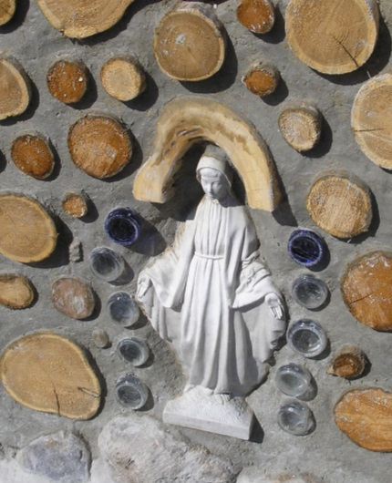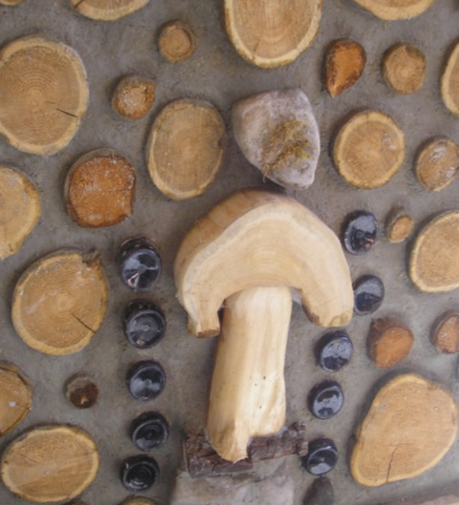 Lastly, I’d like to mention a new mortar mix recipe that I am contemplating. Over the past year, the Adirondack Mycology Club has been growing oyster mushrooms using pelletized kitty litter and hemp hurds. This got me thinking about using hemp, cellulose, mortar sand and green-gray clay at Cedar Eden with hydrated lime as a binding agent. It is similar to hemp-crete, but with a higher plasticity for smooth pointing provided by the cellulose and clay. I’m thinking a mix of this nature could allow for the elimination of cement all together. I plan to experiment with various trials over the coming building season, and hope to report on it in the future. On December 17, 2014, Governor Cuomo signed the industrial hemp bill into law making it legal to grow hemp in New York. Anticipating that there will be lots of cheap hemp hurd waste material in the future to be potentially used for mortar and hemp-crete, this could be a boon to builders. I also plan to grow hemp at Cedar Eden as part of an agricultural pilot project. Few plants are as versatile as the low THC variant of *Cannabis.* It can be grown for fiber, food, fodder, phytoremediation, fuel, and for pharmaceutical purposes. The plant should never have been made illegal to grow in the first place, since you can’t get high on hemp (THC <0.3%).

Two sides of a cordwood wall:

“stoned on mushrooms” and a “blessed virgin”

**Contact Information:** Tom Huber

**Email:** [thuber@paulsmiths.edu](mailto:thuber@paulsmiths.edu)

**Phone Number:** 518.327.6330

**Address:** POB 58, Rainbow Lake, NY 12976