Cordwood Masonry – It’s for the Birds!
by Tom Huber

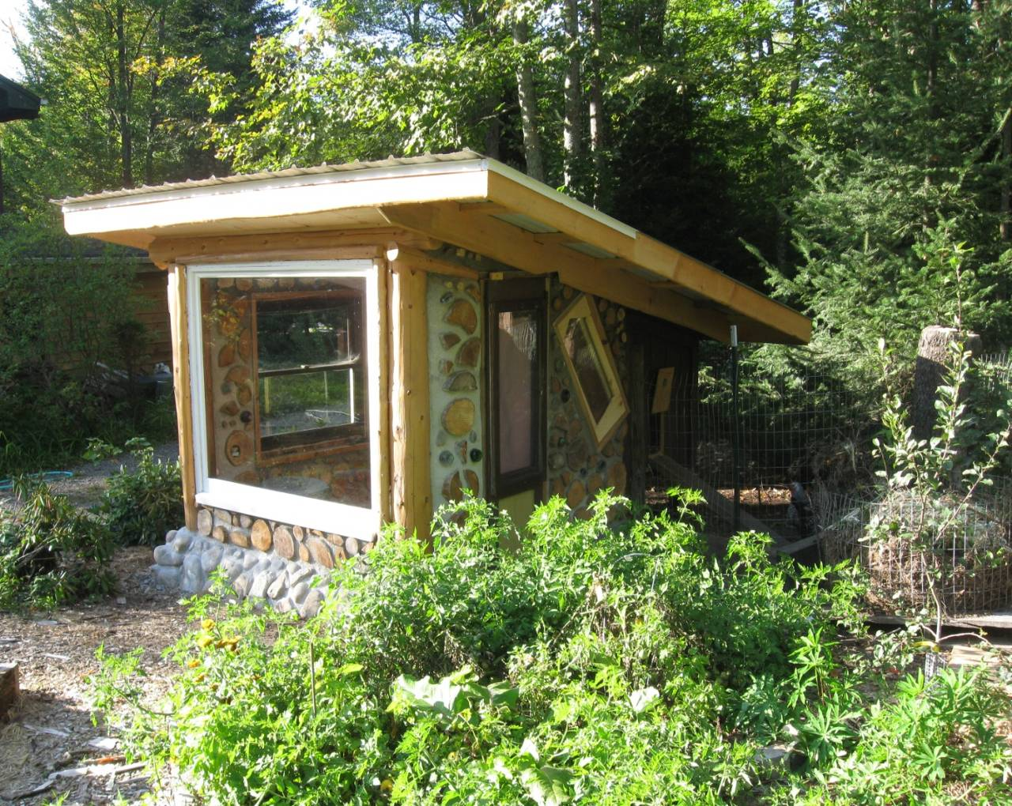

The greatest fine art of the future will be the making of a comfortable living from a small piece of land.
-Abraham Lincoln
Introduction

I didn’t know it at the time, but the construction of our cordwood coop began in the spring of 2006 while scrounging cedar log-ends from a local construction company, which specializes in high-end Adirondack great camps for millionaires. The loads of logs I transported in our small Honda Civic (which I thought was going to be for a home addition project) was stored away for four years to be used later as a small-scale backyard permaculture project. A year had gone by since we relocated from Michigan to the Northern Adirondacks, and I was eager to continue building with cordwood, in part to heal a sense of loss from leaving our former homestead behind. However, more pressing projects on the home-front demanded our family’s attention at the time. The older passive solar home we purchased required a considerable make-over, and the retrofit/remodeling projects took a few years to complete.

Designing with Permaculture in Mind

The development of our homestead in Michigan was informed by much of the back-to-the-land literature of the last century. However, I became aware fairly early on in our “home on the land” venture that taking a piecemeal approach with building, gardening, energy needs, etc, often led to avoidable mistakes. For optimal land management and establishing an elegant household-based economy over time, an integrative design process both before and throughout the homesteading experience would not only lead to fewer regrets in building placement decisions, but would greatly enhance every aspect of human settlement by fully utilizing the wisdom of Mother Nature.
Previously, I was introduced to permaculture design developed by Bill Mollison and David Holmgren, and later completed a permaculture design certificate course. Permaculture can be defined as the conscious design of “cultivated” ecosystems that have the diversity, stability, & resiliency of natural ecosystems. It is a harmonious integration of people and landscape in such a way that the land grows in richness, productivity, and aesthetic beauty. Over the past 30 years and drawing on many disciplines and cultures, permaculture has evolved into a comprehensive set of ethics, ecological design principles, strategies, and methods for establishing a more permanent agriculture. It has also grown into a movement dedicated to establishing a sustainable, regenerative culture to creatively address the problems of diminishing resources and the threatened life support systems now facing the world. Permaculture can be practiced on any scale whether it be transitioning a community from its dependence on fossil fuels or assisting a family in meeting a greater share of its household needs from bountiful, backyard means.

Backyard Forest Farming

One aspect of permaculture especially applicable to modern times is the design and development of backyard edible forest gardens to replace the energy wasteful and ecologically barren suburban lawn. Instead of depleting so many resources on the establishment of a grass monoculture, a perennial polyculture food forest is grown instead. Forest gardens are “stacked and packed” agricultural systems which maximize up to seven layers of vertical space (from the root level to the tree canopy) and the selection of multipurpose plants to create high-yielding, low-maintenance food foraging systems. The concept of succession is put to work by selecting perennial fruit and nut trees, which will provide yields over time, while also providing shade, structure, and pollination potential for other plants. Climbing plants, herbs and vegetables, and ground covers are planted to prevent erosion, fix nitrogen, shade weeds, and perform other ecosystem services while yielding food. All the species selected provide multiple functions and help form symbiotic relationships like those found in natural ecosystems, but they are superior in terms of food production which increases over time. The combined yield of the resilient polycultural system is what makes edible forest gardens worth the time, money, and labor required during the early stages of their establishment.
Our two acre parcel in the Adirondacks was typical of most small land holdings of the region. It consisted largely of temperate deciduous forest productive in terms of wood products, but too shady to grow any appreciable amount of foodstuffs. Classified as Zone 3B for agriculture, the Adirondack’s short growing season combined with poor glacial till soils, and prone to regular cold spells due to higher elevation and frost pockets all present challenges for producing home-grown fruits and vegetables. Ironically, we began our backyard edible forest garden by cutting down a small portion of the forest to create a greater solar opening. First though we had to move a small shed that the previous owner placed along the southern edge of the tree line. This shed was to be later incorporated as part of a small hybrid greenhouse/chicken coop repositioned along the northwestern corner of the edible forest garden.

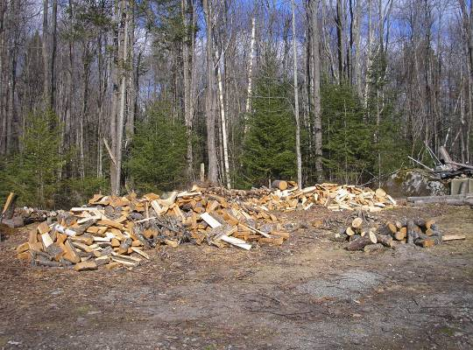
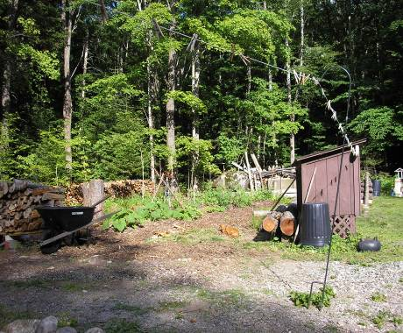

Small shed in the way of felling trees for garden. Shed moved & firewood procured for long heating season.

Siting the Structure to the Sun

The best solar-sited structures in North America have long been the venerable chicken coop. You can still see the skeletal remains of these small, south-facing buildings wherever homesteads and farms once existed. The old-timey farmers knew that both for warmth and light to stimulate egg-laying during the winter months, the best coop was one that utilized the low-angled rays of the winter sun. Although the coops were sun-minded in design, often the much larger farmhouses were not. Instead the farmer relied on the cheap coal bin or woodlot to heat his house and kerosene lamps for interior lighting before the days of rural electrification. Much like in modern times, the house was more often situated to the road than the sun. It deserves noting that on the prairies and windy plains, many farmers did plant a windbreak of trees to buffer the home. (Perhaps the lack of high quality manufactured windows, and knowledge of the good insulative and thermal mass properties of cordwood masonry contributed to poor house design decisions.)
The basic design of our passive solar chicken coop involved a small greenhouse/anteroom consisting of used windows for solar collectors, and walls constructed of cordwood masonry. The floor was designed to be crushed stone or a simple concrete slab insulated with polystyrene foam or Reflectix bubble-wrap. The floor and masonry walls would provide ample mass for thermal storage. Reflectix drapes insulate the glass during cold nights and help retain the stored heat. The ceiling and side and back walls of the attached shed (roosting and laying quarters for the birds) were insulated with a combination of fiberglass, Reflectix, and sheets of foam. It is worth noting the importance of protecting the insulation from the constant pecking action of the birds. They are especially prone to peck at any material that is soft enough to penetrate or has an approximate appearance of food - which can be virtually anything.
After the snow melted, we skidded the small shed to its new resting place using an old wooden beam attached to an axle with steel rimmed wheels and rolling logs. After removing several trees this slightly elevated location now had good solar exposure. It was also situated clear of the recently planted cold hardy apple trees, a key component of the edible forest garden we were planting in stages.
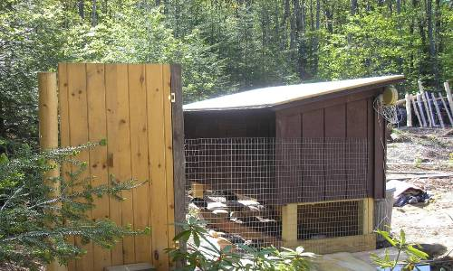
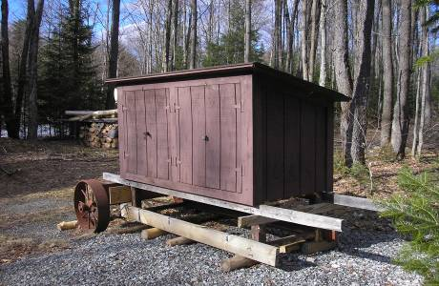

Moving sheds the old-fashioned way. Placement of shed in its new home.
The shed is elevated on pressure treated posts positioned in holes dug approximately to frost line and filled with crushed rock and capped with concrete. Fencing for the chicken run was attached to the back. The birds also have access to the compartment below the inner roosting chamber which contained enough living space for eight egg-laying residents. [It is recommended that chickens have approximately 2 square feet (0.19 square meters) per bird for an adequate roosting/nesting area.] They like to hang-out here on rainy and snowy days, in the same way that humans like to sit out on porches and shoot the breeze.

Ivy’s Birds

Back in Michigan, we raised a small flock of chickens for eggs and as hired hands to assist with our organic gardens. Chickens can help prep gardens with their scratching (tilling) and eating of herbaceous plants (weeds). Of course, what comes out the back end is even more important for providing homegrown fertilizer. Household food scraps and small backyard grain plots can easily and affordably meet a good portion of the diet needs of a small flock of chickens. Both of our daughters have been homeschooled since birth, and our youngest, Ivy missed our Michigan chickens and looked forward to raising some chicks of her own. So as part of her homeschool curriculum, she organized a group purchase order of 60 chicks with several families in our area.
She researched the pros and cons of various online and local vendors, read a couple books on the subject regarding the best cold-hardy breeds for the Adirondacks, and finally selected Meyer Hatchery located in Polk, Ohio. She particularly liked the fact that this company does not grind up the “throw-away” male chicks that are not generally preferred by customers (and their crowing-aversive neighbors). They also guarantee that 90% of the chicks ordered will be females. In our case all eight of our chickens were thankfully hens. Ivy’s assigned names include the days of the week, plus Edelweiss. The breeds (Buff Orpington, Silver Laced and Golden Laced Wyandottes) that Ivy selected are even-tempered, possess low profiled combs – which are not as prone to freezing as larger, fleshier ones, and lay medium to large brown eggs. [Although our winter has so far been a mild one this year (2010-11), we had a recent cold snap where temps fell at night to -30. The birds appreciated the heat lamp in the coop at night, and along with the bright sun reflected off the snow during the ensuing days resulted in full egg production demonstrating the overall workability of the solar-minded coop.]
By the time the chicks were delivered in early April, we had the small shed in place so that in a few weeks they could be moved from their cardboard box in the garage to their new home. The main phases of the construction process continued throughout the spring and summer months as time permitted.

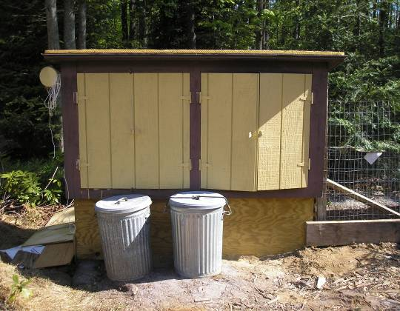
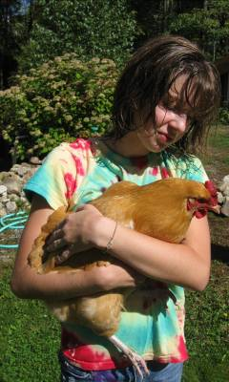

Wet-head Ivy with Sunday. Small shed converted to small coop awaiting roof & walls.

Foundation and Frame

The building project was hybrid in another respect. The passive solar greenhouse attached to the roosting quarters consists of both stone and cordwood walls. But first, the foundation needed to be laid and the simple post and beam frame erected. The foundation required digging two holes for setting the footers for two posts which frame the south wall. In the Adirondacks, even small digging operations can sometimes result in hitting boulders the size of a small house just a few feet below grade. The first hole was fairly easy digging except for having to cut out a variety of tree roots. However, about two feet down in the second hole I hit a chunky boulder the size of a Samurai’s belly. I thought about setting the post on top of it, but eventually kept digging and was able to pry the stone out of the hole using a makeshift ramp. The prodigious stone now stoutly sits in the ring of our outdoor stone fire pit.
I then half-filled the four foot deep holes with good drainage rubble and inserted a two foot long cut-off of a 6”X6” pressure treated post in each hole - leftovers from another building project. Using a level, I made sure the protruding stubs were plumb and then poured a stiff concrete mix around them of about a foot deep. After the concrete hardened, two balsam fir posts cut the previous winter were set atop the pressure treated cut-offs, braced with 2”X4”s and the bottoms anchored with exterior screws. A round cedar log served as a header beam on top of the posts, supporting the rafters and metal roofing.

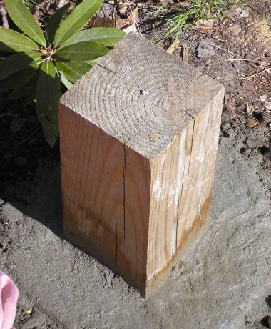
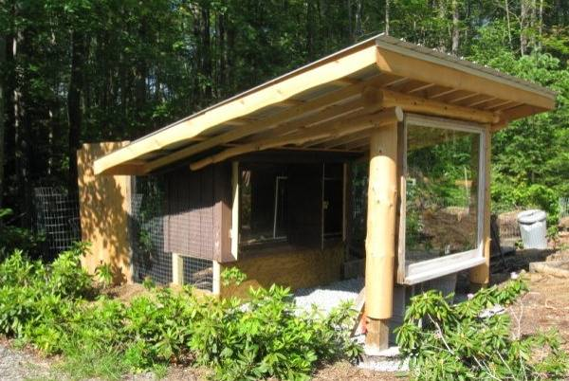

Pressure treated pier-footer for corner post. Inner chamber of coop, frame, and roof in place.

Salvaged, Bartered, and Boughten

Much of the design and construction of the passive solar coop was determined by the building materials procured. Along with the cedar log-ends acquired for free back in 2006, were added a host of other salvaged and bartered materials. In exchange for house-sitting for a friend who had recently moved to Idaho for a new job, I was gifted several sheets of foam insulation and metal roofing, pressure treated plywood, fencing material, rough sawn lumber and various sizes of timbers. The timbers were employed for raised bed gardens and most of the building materials were reused in the coop project. The only purchased materials for the project were 2”X4”s for the roofing system and cement for the stone and cordwood masonry portion of the walls. The windows were free for the taking. I had already set the posts when we found the large south-facing window, which serendipitously fit perfectly into the opening.

Stonework, Foam & Inner Cordwood

Once the frame and roof was constructed, a rubble trench foundation was dug between the posts with water drainage directed away from the walls. The roof system includes a two-foot overhang to keep rain and snow away from the foundation and walls as well. On top of the rubble trench was placed 12” wide strips of 2” polystyrene foam. Foam was also secured vertically on top of the horizontal strips and screwed to the posts of the interior shed and foundation posts. A short tapered stone wall was then built on top of the foam on the outside, and a short 7” thick cordwood wall was faced on the inside. The stones were leaned and mortared to the foam, and anchored to the posts and inner cordwood wall with the use of brick ties pushed through the foam. The joints were then raked and a mortar pointing mix was applied.

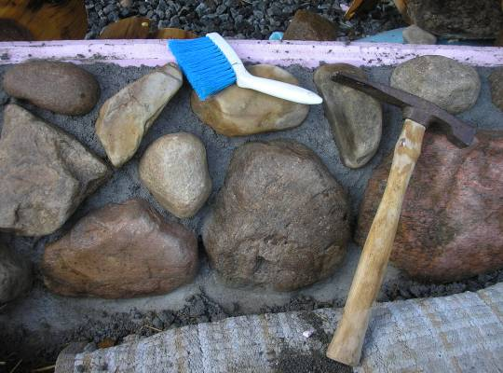
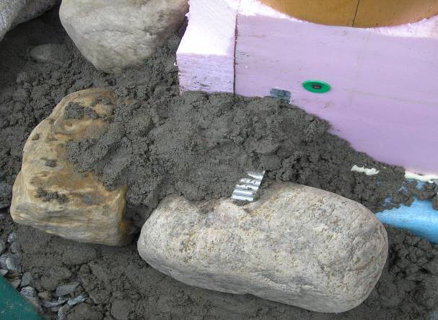

Corner stones mortared & anchored to foam and post. Tools used for raking joints, making ready for pointing.

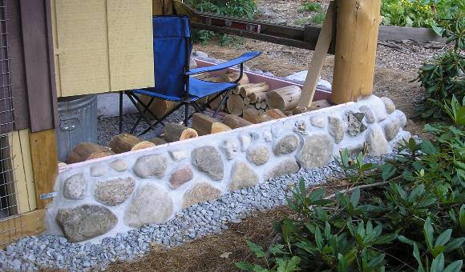
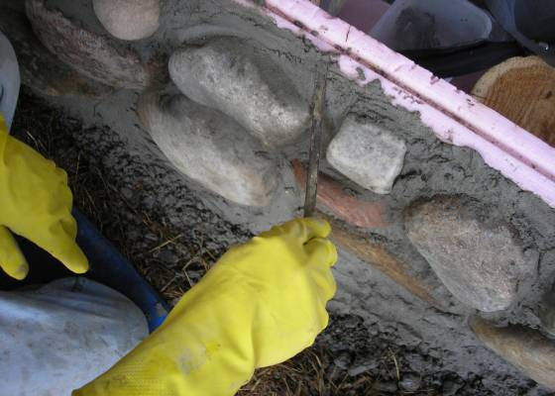

Tuck pointing stonework. Cured stonework with mortar pointing ready for cordwood.

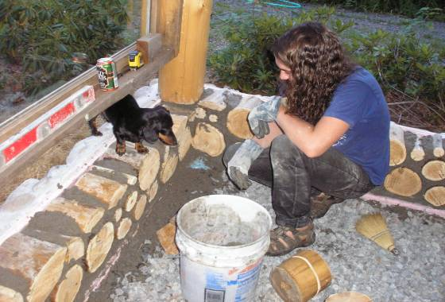
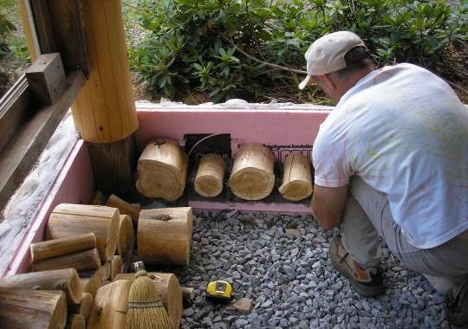

Foam sandwiched between stone and cordwood. Supervisor Sidney inspects apprentice Benji’s log-end work.

When finished, a short stone, foam and cordwood hybrid wall was ready to accept 11” thick log-ends for the remainder of the walls. Stone on the outside gives the wall greater durability at grade level and the foam insulation increases the R-value of the stem wall. Since the greenhouse portion of the structure is only 6’X6’ it is just large enough for storing chicken feed and growing trays of microgreens. It is also a cozy, enjoyable place to hang-out with the birds in the evenings and lookout over the garden.

Paper-Enhanced Mortar Mixes

Our last two cordwood construction projects in Michigan involved the experimental use of different paper-enhanced mortar (PEM) recipes with good results (see Paper Enhanced Mortar by Alan Stankevitz in Cordwood Building: State of the Art by Rob Roy). After the success of the early trials, I quickly became a convert to PEM mixes due to the higher insulative values, great plasticity/workability, and no-to-low mortar/log-end shrinkage/gapping. So I knew that the mortar recipe for the greenhouse/coop project would be a PEM concoction. Initially, I was planning to try out a lime-putty and paper mix, but I was unable at the time to find a nearby supplier of hydrated lime. I was also concerned about the high moisture content of the mix and slow drying time, and whether I would have the cordwood walls built in time before freezing weather set in. A good bit of my free time was also taken up by a cabin construction project, which will also include walls of cordwood masonry. The experimental mortar recipes for the coop project served as an opportunity to conduct test-trials for the cabins walls to be built in 2011.
I started out by reviewing notes on PEM mixes from our Michigan trials and conducting a literature review on the subject. I decided on a base mix similar to Alan Stankevitz’s given his positive results (www.daycreek.com), using Type S masonry cement instead of Type N, and experimenting with three different forms of paper. The volume by proportion of paper, cement, and sand, were identical to Alan’s favorite mix:

2 parts slurried paper, 2 parts sand, 1 part type S masonry cement

The sand was free for the taking from a pit just a few miles away. The only material to be varied was the paper portion consisting of either shredded newsprint, shredded office paper, or bags of purchased cellulose. The idea of using bales of cellulose occurred to me about six years ago just prior to leaving Michigan, and I was curious to see how it would perform compared to previously tested papercrete-like materials. I also wanted to determine how easily the paper-based materials would mix with the other ingredients, by hand, in a wheelbarrow in addition to determining durability, strength and other performance characteristics.
Just like in Michigan, I had access to free shredded office paper from the college where I work. This material worked fine in the past, but even with proper soaking was stiffer by comparison than the slurried newsprint that Alan used. His results were also very similar to that of Jim Juczak’s who had access to free batches of paper sludge from a mill near his home in Adams Center, New York.
So the first mix contained shredded office paper, the second - shredded newsprint, and the third - cellulose purchased in compressed bales (GreenFiber, 2.2 Cu. Ft. Natural Fiber).

PEM Recipe Results

The first several wheelbarrow batches of mortar for log-end laying consisted of soaked office paper, mixed together with the sand and cement. A 55 gallon plastic barrel (or similar) works well for soaking the paper for several hours prior to use. Most of the water is wrung out of the paper by hand and measured into a five gallon pail. Next, it is spread out onto half of the premixed sand/cement in the wheelbarrow with the remainder of the sand/cement sprinkled on top. While folding/mixing/kneading the materials, the longer shredded bits of paper are ripped into smaller pieces. The consistency of the mix is quite squishy from the water retained in the paper, so no additional water is required. This same process was repeated throughout the wall building process; the only difference was the type of paper used.
The shredded office paper and newsprint “behaved” similarly with the only appreciable difference being the softer pulpiness of the newsprint as compared to the thicker, stiffer paper. This difference could’ve been minimized by extended soaking of the paper and the mechanical use of a high-speed paddle drill, which is often employed by masons who use paper-enhanced mortar. The one drawback of the hand-made, “no-power mix” is the occasional appearance of paper pieces when tuck pointing the mortar around the log-ends. If not careful, gobs of paper can become segregated if the ingredients are not evenly distributed and blended.
The PEM batches consisting of soaked cellulose were superior in terms of ease of mixing, plasticity, lighter in color, and smooth pointability. The mortar was characterized by higher absorption and retention of water, which enabled easy pointing around log-ends with a bent butter knife followed by smooth finishing with a small brush. Although the bales of cellulose are an extra cost (compared to free newspaper and office paper), the lower labor involved and positive results justify the purchase. It also helps that the product has a very low embodied energy content, and is widely available at most retail building supply stores.
The only drawback to the use of commercial cellulose is that it smells. When cellulose is mixed with water, an ammonia smell is detected due to the presence of ammonium sulfate. Common fire retardants added to cellulose insulation include borax, boric acid, and ammonium sulfate. Apparently, there is a shift in the cellulose industry toward ammonium sulfate over borax due to its superior fire-retarding performance. (Some studies indicate that borates are more prone to leach out overtime.) After I first smelled ammonia in a PEM mix, I Google searched and found similar reports among papercrete users. The presence of ammonia produces little risk when mortar mixing in an open-air environment, but a protective ventilator mask is recommended in tight interior spaces.

No Shrinkage

Although the PEM recipe involving cellulose was the overall winner by comparison, all three mixes show no signs whatsoever of shrinking or separating from the log-ends. This is identical to what we observed in Michigan albeit using different PEM mixes. The other similar finding is the presence of a few tiny hairline cracks in the mortar in one small area, probably due to excessive moisture in the mix. Given the use of short 11” log-ends, no sawdust chase was used in the center of the mortared section of the walls. The mortar bed was solid and recessed about 3/4” from the face of the log-ends.
Overall I was pleased with the results of all the recipes experimented with to date. However, I plan to add one other ingredient to the mix for the cordwood cabin project this year: hydrated lime. I believe the addition of lime (in dry form) will brighten the mix to a whiter color while also contributing other positive characteristics to the mortar. Hydrated lime is well-known for its self-healing traits through re-calcification enabling cracks to be mended overtime. It also possesses high adhesive and retentive characteristics, along with superior plasticity which allows for subtle movement of mortar without cracking. I believe all of these positive attributes will contribute to the success of the Cellulose-Enhanced Mortar (CEM) mix by the simple addition of a shovelful of hydrated lime. I hope to have good results to share by this year’s summer solstice.
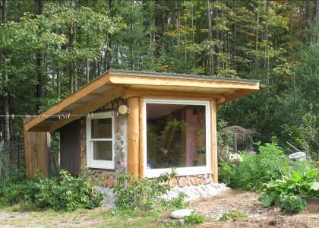
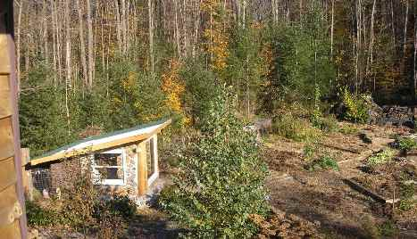

Overview of emerging edible forest garden and coop. Southwest view of greenhouse/coop & solar clothes dryer.

Contact Information: Tom Huber
Email: thuber@paulsmiths.edu
Phone Number: (518) 327-6330 (daytime)
Address: P.O. Box 58, Rainbow Lake, NY 12976

